

***Flynn’s Arcade***

**Design Brief:**

Flynn's Arcade has been slowly losing money as the trend for accessing video games has moved away from social 'video game arcades' to at home 'video game consoles' such as the Atari & Commodore 64. Flynn wants to reposition his business as a venue for selling new games and trading used games. Flynn wants you to design and create ‘alpha phase’ website that communicates his new business model. (More information on Flynn’s Arcade: <http://tron.wikia.com/wiki/Flynn's_Arcade>)

**Areas of Investigation (Research)**

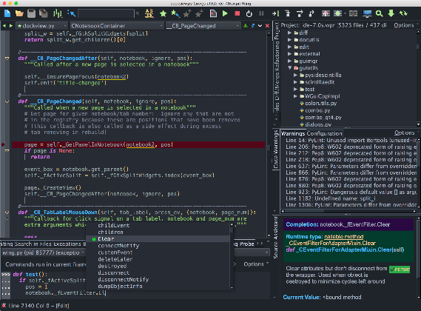

***IDE***

Integrated Development Environment (IDE) is a software application that combines all of the features and tools needed by a software developer. It's graphical in nature, meaning that it uses windows and controls like buttons to display information and accept input from the user. For example, tools can include.

**CMS**

A content management system, often abbreviated as CMS, is software that helps users create, manage, and modify content on a website without the need for specialized technical knowledge.

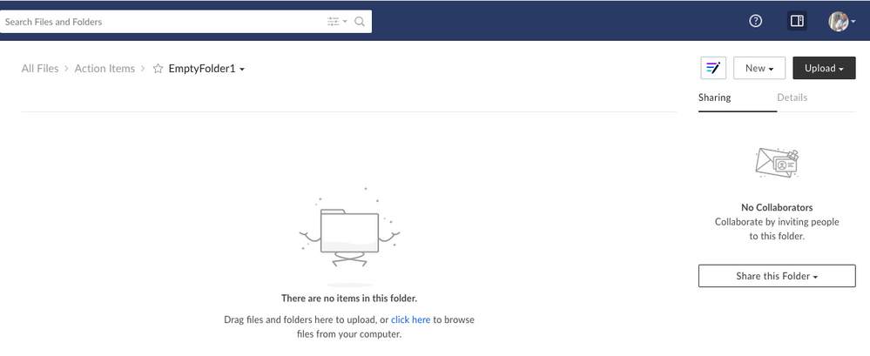**Drag and drop**

Drag and drop is a functionality by which users can select an object or a section of text and can move it to a desired location and "drop" it there. Drag and drop is a part of most graphical user interfaces, but is not found in all software.

Background research on Flynn and his design aesthetic

Kevin Flynn was gifted a computer programmer and he created some bestselling video games for company named ENCOM which included space paranoids, matrix Blaster, Vice Squad, and light Cycles.

Research on data communications and its implications for web design.

Data communications (DC) is the process of using computing and communication technologies to transfer data from one place to another, and vice versa. It enables the movement of electronic or digital data between two or more nodes, regardless of geographical location, technological medium or data contents.